**SQL Script**

**create database cricket;**

**use cricket;**

***\*\* CREATE TABLE COMMAND \*\****

**CREATE TABLE match_data (**

**match_id INT,**

**season VARCHAR(255),**

**start_date VARCHAR(255),**

**venue VARCHAR(255),**

**innings INT,**

**ball INT,**

**batting_team VARCHAR(255),**

**bowling_team VARCHAR(255),**

**striker VARCHAR(255),**

**non_striker VARCHAR(255),**

**bowler VARCHAR(255),**

**runs_off_bat INT,**

**extras INT,**

**wides INT,**

**noballs INT,**

**byes INT,**

**legbyes INT,**

**penalty INT,**

**wicket_type VARCHAR(255),**

**player_dismissed VARCHAR(255),**

**other_wicket_type VARCHAR(255),**

**cricsheet_id INT**

**);**

***\*\* CONVERTING DATE COLUMN TO DATE FORMAT \*\****

**update match_data**

**set start_date = str_to_date(start_date, '%d-%m-%Y');**

**set global local_infile=true;**

**SET GLOBAL local_infile=1;**

***\*\* LOAD DATA TO MATCH_DATA\*\****

**LOAD DATA LOCAL INFILE "C:/Users/jwala/Downloads/Interview Assignment- Data Analyst/match_data.csv"**

**INTO TABLE match_data**

**COLUMNS TERMINATED BY ','**

**OPTIONALLY ENCLOSED BY '"'**

**ESCAPED BY '"'**

**LINES TERMINATED BY '\n'**

**IGNORE 1 LINES;**

***\*\* CREATE TABLE COMMAND FOR match_info TABLE \*\****

**CREATE TABLE match_info (**

**id INT,**

**season VARCHAR(255),**

**city VARCHAR(255),**

**match_date VARCHAR(255),**

**team1 VARCHAR(255),**

**team2 VARCHAR(255),**

**toss_winner VARCHAR(255),**

**toss_decision VARCHAR(255),**

**result VARCHAR(255),**

**dl_applied int,**

**winner VARCHAR(255),**

**win_by_runs INT,**

**win_by_wickets INT,**

**player_of_match VARCHAR(255),**

**venue VARCHAR(255),**

**umpire1 VARCHAR(255),**

**umpire2 VARCHAR(255),**

**umpire3 VARCHAR(255)**

**);**

**SELECT * FROM match_info;**

***\*\* LOAD DATA INTO match_info TABLE\*\****

**LOAD DATA LOCAL INFILE "C:/Users/jwala/Downloads/Interview Assignment- Data Analyst/match_info_data.csv"**

**INTO TABLE match_info**

**COLUMNS TERMINATED BY ','**

**OPTIONALLY ENCLOSED BY '"'**

**ESCAPED BY '"'**

**LINES TERMINATED BY '\n'**

**IGNORE 1 LINES;**

**update match_info**

**set match_date = str_to_date(match_date, '%d-%m-%Y');**

**-- 1. Batter**

**## overrall top 10 batsman**

**DROP view top_10_batsman_overrall;**

**create view top_10_batsman_overrall AS**

**SELECT ipl_bat.* FROM**

**(**

**select striker,**

**count(distinct match_id) as total_matches_played,**

**sum(runs_off_bat) as total_runs_scored,**

**ceil(sum(runs_off_bat) /count(distinct match_id)) as batting_avg,**

**dense_rank() OVER(order by sum(runs_off_bat) DESC) AS run_rnk**

**from match_data**

**-- where STRIKER IN (SELECT DISTINCT STRIKER FROM match_data WHERE STRIKER NOT IN (SELECT DISTINCT BOWLER FROM match_data))**

**group by 1 order by 3 desc**

**) AS ipl_bat where run_rnk <=10;**

**\*\* OUTPUT\*\***

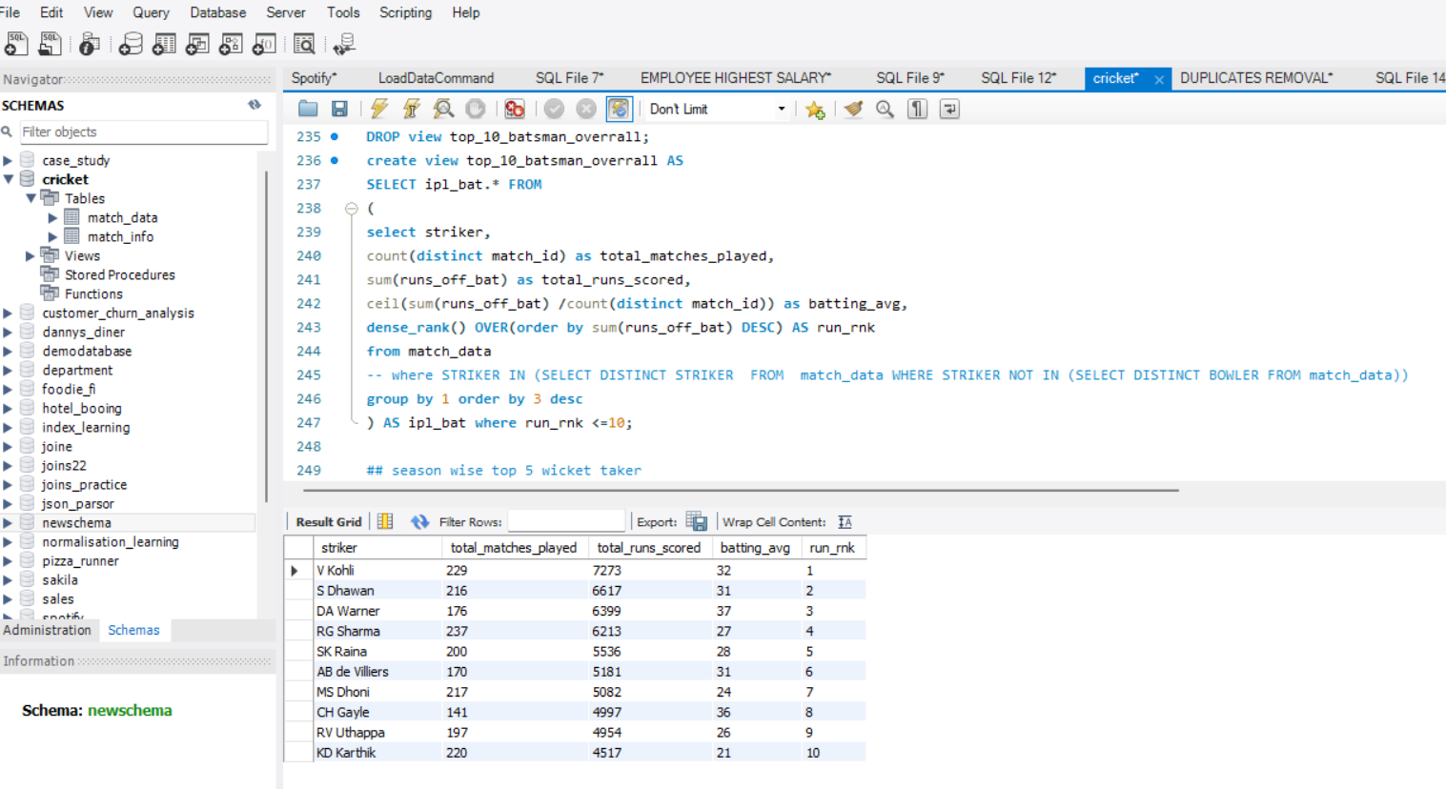

**-- #############################################################################**

**-- 2. Bowler**

**-- ## overrall top 10 bowler**

**DROP VIEW top_10_bowler_overrall;**

**create view top_10_bowler_overrall AS**

**SELECT ipl_wick.* FROM**

**(**

**select bowler,**

**count(distinct match_id) as total_matches_played,**

**count(case when wicket_type is not NULL then 1 end) as total_wickets_taken,**

**ceil(count(case when wicket_type is not NULL then 1 end) /count(distinct match_id)) as wick_avg,**

**dense_rank() OVER(order by count(case when wicket_type is not NULL then 1 end) DESC) AS wick_rnk**

**from match_data**

**-- where BOWLER IN (SELECT DISTINCT BOWLER FROM match_data WHERE BOWLER NOT IN (SELECT DISTINCT STRIKER FROM match_data))**

**group by 1 order by 3 desc**

**) AS ipl_wick where wick_rnk <=10;**

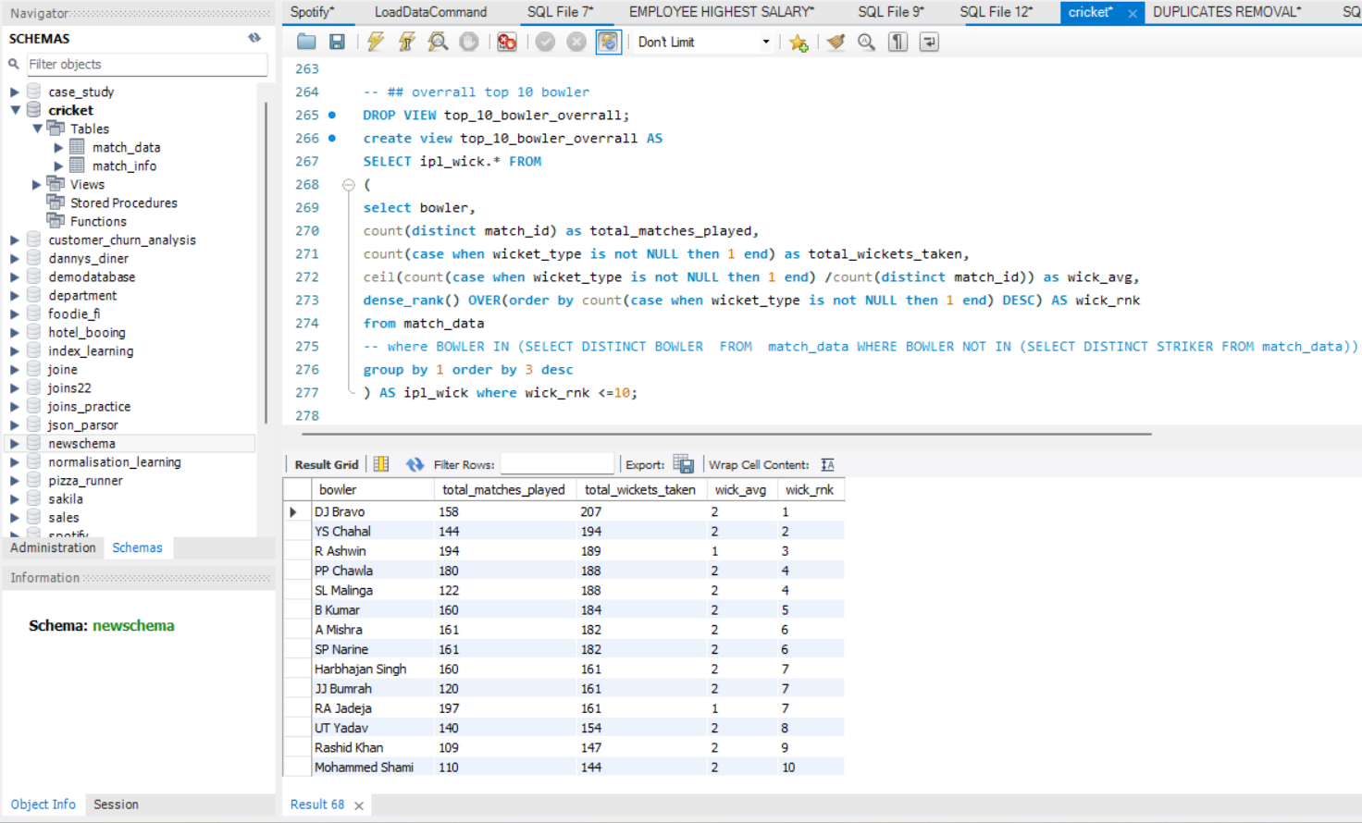

**-- 3. Batting all-rounder**

**SELECT**

**m1.striker, COUNT(DISTINCT m1.match_id) as total_match_played,**

**COALESCE(SUM(m1.runs_off_bat), 0) AS total_runs,**

**COALESCE(wickets_taken.wicket_count, 0) AS wickets_taken,**

**ceil(COALESCE(SUM(m1.runs_off_bat), 0)/COUNT(DISTINCT m1.match_id)) as batting_avg,**

**ceil(COALESCE(wickets_taken.wicket_count, 0)/COUNT(DISTINCT m1.match_id)) as wicket_avg**

**FROM**

**match_data m1**

**LEFT JOIN (**

**SELECT**

**bowler,**

**COUNT(wicket_type) AS wicket_count**

**FROM**

**match_data**

**WHERE**

**wicket_type IS NOT NULL**

**GROUP BY**

**bowler**

**) wickets_taken ON m1.striker = wickets_taken.bowler**

**GROUP BY**

**m1.striker**

**having wickets_taken > (SELECT count(case when wicket_type is not NULL then 1 end)/ COUNT(DISTINCT BOWLER) AS avg_wkt FROM match_data)**

**order by total_match_played desc, total_runs desc, wickets_taken desc, batting_avg desc, wicket_avg desc;**

**-- 4. Bowling all-rounder**

**SELECT m1.bowler,**

**COUNT(m1.wicket_type) AS wicket_count ,**

**runs_scored.total_runs AS run_scored**

**FROM**

**match_data m1**

**LEFT JOIN (**

**SELECT striker,**

**COALESCE(SUM(runs_off_bat), 0) AS total_runs**

**FROM match_data**

**GROUP BY striker**

**) runs_scored ON m1.bowler = runs_scored.striker**

**GROUP BY m1.bowler**

**order by wicket_count desc, run_scored desc;**

